**Title: Homicides increased inequality of lifespans in Mexico and its States, 2005-2015**

**Authors:** José Manuel Aburtoa & Hiram Beltrán-Sánchezb

**Author affiliations:**

a Institute of Public Health- Unit of Biodemography, University of Southern Denmark, Odense 5000, Denmark.

b Department of Community Health Sciences at the Fielding School of Public Health and California Center for Population Research, Center for Health Sciences, Los Angeles, California, USA.

**Corresponding author:**

José Manuel Aburto

Email: [jmaburto@health.sdu.dk](mailto:jmaburto@health.sdu.dk)

Tel. number: +45 65 50 94 16

Affiliation: Institute of Public Health- Unit of Biodemography, University of Southern Denmark

Address: J.B. Winsløws Vej 9. DK-5000 Odense C, Denmark

**Classification:** Violence, Population Health and Demography

**Keywords:** violence, homicide, lifespan variation, life expectancy, demography.

**Abstract:**

Violence is a major public health issue in Latin America. Some countries, including Mexico, have undergone an upsurge in homicides recently. In Mexico, homicide-rates doubled between 2007-12. Because of this, male life expectancy stagnated in the period 2000-10. However, life expectancy masks inequality of lifespans. We analyze lifespan variation in the context of rising violence and study the effect of the sharp increase in homicides. We use ‘years of life lost’ as an indicator of lifespan variation and study how it changed from 1995 to 2015, for females and males in Mexico and its 32 states. Determining the ages and causes-of-death that contributed the change in life expectancy and lifespan variation, we found that homicides increased lifespan variation in every state of Mexico in the period 2005-15. This study is important for policy makers in Mexico and other Central American countries that are experiencing similar increases in homicides.

**Introduction**

Violence has become a major public health issue in Latin America since the end of the 20th century [1]. This region currently experiences the highest homicide rate in the world (over 16.3 per 100,000 people), with some countries in Central America, including Mexico, undergoing an upsurge in homicides since the first years of the 21st century [2]. In Mexico, for example, homicide rates doubled between 2007 and 2012 (from 9.3 to 18.6) [3]. As a result of this increase, along with an increasing burden of diabetes, male life expectancy in Mexico stagnated in the period 2000-10 [4]. At the subnational level, evidence indicates that gains in life expectancy due to causes amenable to medical service throughout 2000-10, such as infectious, respiratory diseases and birth conditions, were wiped out by the increase of homicide and diabetes mortality in each of the 32 states in Mexico with large regional variations [5].

Trends in life expectancy are important and have been studied in Mexico and its states [4-6]. However, life expectancy masks substantial heterogeneity in individual mortality trajectories [7, 8], referred here as lifespan variation. Variability in ages-at-death expresses a fundamental inequality among individuals [9], and it has arisen as an important topic since it addresses the growing interest in health inequalities [10]. Studying both life expectancy and lifespan variation adds an important dimension to the study of population health because these indicators represent individuals’ decisions based not only on their expected lifetime, but also on the uncertainty in their timing of death [11]. Most studies have found a negative association between these two measures, suggesting that as life expectancy increases, variation in lifespans decreases [8, 12-14]. However, at the subnational level some evidence suggests that increases in lifespan variation may simultaneously occur with increases in life expectancy, mostly due to a slowdown in mortality improvements in working ages (e.g., premature mortality) [15, 16]. This is particularly relevant for countries that have experienced an upsurge in homicides since this increase has mainly affected working age individuals.

In Mexico, for example, homicide mortality is concentrated between ages 15 and 50, affecting mainly males. We thus hypothesize that the Mexican population may be experiencing increases in lifespan variation due to the rise in homicides in tandem with improvements in overall life expectancy at the subnational level. We also expect larger changes in lifespan variation among men and uneven variability across states in the country due to the changing dynamics of violence and homicides in Mexico [17]. For instance, states in the Northern part of Mexico (e.g., Chihuahua, Durango and Sinaloa) experienced the largest losses in life expectancy due to homicides between 2005-10 [5] and it is likely they also exhibit large lifespan variation in the country, although this impact may be larger in other states as homicides spread throughout the entire country in recent years [18]. However, since the more pronounced fluctuation in age-specific mortality occurred over working ages [5], it is unclear what the net effect would be on lifespan variation but it certainly had an effect on premature mortality. On the other hand, there have been mortality improvements in the country at younger ages, which have been a priority in the country since the 1990s (e.g., birth-related conditions) [19, 20]. These improvements could have a substantial effect on reducing variation in lifespans, particularly in historically poor states, which are mostly concentrated in the South.

This paper makes three main contributions. First, it contributes to the literature on lifespan variability and inequalities in health in the context of rising homicides. Most literature in this area focuses on social determinants of health (e.g., socioeconomic status and health risk factors) as proximate determinants of lifespan variability and health inequality. In contrast, our paper highlights the role of violence, and its ultimate consequence in the form of homicides, among young adults on increasing lifespan variability. To date, no comprehensive study of lifespan variation has focus on the effect of the sharp increase in homicide mortality under periods of life expectancy decline or stagnation. A second contribution is its focus on Mexico. Mexico is experiencing a growing violence associated with the war on drugs that started in the last decade, making the increase in homicides a serious health policy concern. Understanding the consequences that homicides have on population health is important for Mexican policy makers, and for policy makers in other countries that are experiencing similar increases in homicides such as Honduras and El Salvador in Central America. Finally, this analysis contributes to our knowledge of regional variation in lifespans.

.

In this article we use ‘years of life lost’ ($e^{†}$) as an indicator of lifespan variation [21]. This measure allows us to analyze thoroughly premature mortality, and it also has an important public health interpretation because it quantifies the average life expectancy loss attributable to death [22] . We analyzed how lifespan variation changed over a 20-year period, from 1995 to 2015, for females and males in Mexico and its 32 states, and determined the ages and causes of death that contributed the most to the observed change in life expectancy and lifespan variation.

**Study data and Methods**

We used data on deaths from vital statistics files publicly available through the Mexican National Institute of Statistics and Geography [23]. These data include information on cause-of-death by age, sex, and place of occurrence from 1995 to 2015. Additionally, we used population estimates corrected for completeness, age misstatement, and international migration available from the Mexican Population Council to construct age-specific death rates by age, sex and state [24].

***Cause-of-death classification***

We classified deaths into eight categories according to previous studies targeting the main causes of death in Mexico [5, 25] using the concept of amenable/avoidable mortality [26, 27]. This concept assumes that there are some conditions that should not cause death in presence of timely and effective medical care. Deaths due to these conditions are a proxy for the performance of health care systems [26].

The first category includes conditions amenable to medical service. It refers to mortality that could be reduced by primary or secondary prevention, and timely medical care (for example, birth conditions, infectious and respiratory diseases). We analyzed separately diabetes, ischemic heart diseases (IHD), lung cancer, cirrhosis, and road traffic accidents because the first two are leading causes of death in Mexico [4], and all of them are amenable to health behavior and medical service [5]. The last (eighth) category includes the residual causes of death labeled ‘Rest’. For details on how deaths were classified using the International Classification of Diseases [ICD] see the Supplemental Material. To mitigate biases due to misclassification of causes of death, we focus on causes for deaths occurring below age 85 since coding practices above that age are less reliable due to the presence of comorbidities.

We study two comparable 10-year periods, between 1995 and 2005, and from 2005 to 2015. This allowed us to identify a period of mortality improvements (1995-2005) in which life expectancy increased by 2.1 and 4.3 years for males and females, respectively [24] and homicide rates fell down among young ages [28]. The second period (2005-2015) is characterized by a period of life expectancy stagnation, particularly for males (around 72 years) and slow progress for females (from 76.7 to 77) accompanied by an unprecedented rise in homicide mortality [5].

***Lifespan variation indicator***

Several dispersion measures have been proposed to analyze lifespan variability [8, 29]. In this study, we use $e^{†}$ as a dispersion indicator and we refer to it as “lifespan variation”. It is defined as the average remaining life expectancy when death occurs, or life years lost due to death [13, 21]. For example, if in a cohort of newborns all die at the same age then the value of $e^{†}$ is zero; to the extent that death occurs at different ages, those who die “prematurely” will die before their expected lifetime, contributing lost years to life disparity. In lifetable notation, it is defined as:

$$e^{†}= -\int_{0}^{ω}{l\left(x\right)\text{μ(}x)e\text{(}x)\text{d}x}=-\int_{0}^{ω}{l\left(x\right)\text{ ln}l\left(x\right)\text{d}x}$$

where $l\left(x\right)\text{, } \text{μ(}x), e\text{(}x)$ and $ω$ are the survival function, the force of mortality, life expectancy at age $x$, and the open-aged interval, respectively.

This indicator was chosen because it has an easy to understand interpretation and it is also easy to decompose allowing us to quantify the impact of age and cause-specific mortality on changes in life disparity over time [22, 30]. An additional advantage is the high correlation between $e^{†}$ and other measures of variability in ages at death (e.g., life table entropy, coefficient of variation, or the Gini coefficient) which suggests that our main results would be very similar to those obtained with any of these additional measures [29].

***Demographic and statistical methods***

To mitigate random variations in cause-of-death classification, we smoothed cause-specific death rates over age using a 1-d p-spline separately by year, sex and state [31]. We then rescaled the smoothed cause-specific deaths to all-cause death rates to maintain the overall mortality level by year, sex, and state. Using these mortality rates we computed period life tables for males and females for each year-state in the study period (1995 to 2015) following standard demographic methods [32]. Finally, we computed life expectancies (e0) and life disparities ($e^{†}$) for each year and estimated the age- and cause-specific contributions to differences between the periods 1995-2005 and 2005-2015, using standard decomposition techniques [33]. All the analyses were carried out using R [34] and are fully reproducible from the Supplemental Material. In addition, to analyze state-specific mortality profiles and changes along other period from 1995 to 2015 we created an interactive app to perform sensitivity analyzes available [here](https://goo.gl/H1y1R6).

**Results**

**Changes in life expectancy and lifespan variation at the national level**

In Figures 1-4, we show results for males because the showed the largest changes caused by homicides, results for females are reproduced in the Supplemental Material figures S1-S4.

Figure 1 shows age- and cause-specific contributions to the change in male life expectancy at birth between 1995 and 2005 (Panel A) and between 2005 and 2015 (Panel B). Vertical values enclosed in rectangles represent age-specific contributions (in years), while the length of the bars correspond to cause-specific contributions by age (also in years). Overall cause-specific contributions across all ages are shown in the panel’s legend in parenthesis.

Life expectancy in Mexico increased two years for males (from 69.2 to 71.2) and 1.3 years for women, changing from 75.4 to 76.7. Figure 1 shows that the progress made in reducing perinatal conditions and ages below age 5 is equivalent to almost one year of increase in life expectancy for males. Over the full age span, reductions in mortality from conditions amenable to medical service (AMS) (blue bars) and homicides (red) account for more than one and a half years of increase in life expectancy for males and over one full year in females between 1995 and 2005. Opposing this, diabetes and ischemic heart diseases (IHD) caused a reduction of over half a year in the same period, mainly in ages above 40 in both sexes.

From 2005 to 2015, the progress in increasing life expectancy was slowed down by half for males, compared to the previous decade, while female life expectancy increased an additional year. Homicides contributed the most to the slowdown in life expectancy (-0.3 years), mostly between ages 15 and 60. Diabetes and IHD continued to deteriorate, bringing down life expectancy by 0.26 years in males and 0.15 in females. In males, progress in reducing deaths from lung cancer and cirrhosis contributed to the rise in life expectancy. Conditions amenable to medical service continued increasing life expectancy, albeit at a slower pace than ten years before.

[Figure 1 about here]

Figure 2 shows similar information to Figure 1 corresponding to lifespan variation ($e^{†}$). Lifespan variation decreased throughout the entire period 1995-2015 for males and females at the national level. However, stronger reductions on $e^{†}$ were made between 1995 and 2005 changing from 16.5 to 15.3 for males, and from 14.3 to 13.4 years for females. In the following ten years, 2005-2015, reductions represented almost half of the improvements made in the previous period (1995-2005). Homicides and conditionals amenable to medical service account for most of the decrease in $e^{†}$ between 1995 and 2005 for males, -0.24 and -0.61 years respectively. Diabetes, contributed negatively to the change in lifespan variation, mainly because of mortality deterioration above age 70 in both males and females. Like males, most reduction on $e^{†}$ were caused by medically amenable conditions.

Between 2005 and 2015, the increase in homicide mortality had a positive impact on lifespan variation of 0.16 years in ages below age 60 for males, and a negligible impact for females. Opposing this, improvements in mortality in road traffic accidents (-0.11) and cirrhosis (-0.11) decreased variation in lifespans. Importantly, deteriorations in diabetes mortality in ages above 70 continued helping reducing lifespan variation.

[Figure 2 about here]

**Changes and cause-specific contributions to life expectancy and lifespan variation at state level**

Figure 3 shows changes in life expectancy (panel A) and in lifespan variation (panel B) for males in each of the 32 states in Mexico between 1995 and 2005 (blue dots) and between 2005 and 2015 (red triangles) by region . Every state increased life expectancy between 1995 and 2005 (panel A) with an additional year. However, between 2005 and 2015, the progress was slowed down and every state in Mexico experienced lower gains in life expectancy than the previous decade. Some states even experienced reductions in life expectancy, such as Chihuahua and x.

Opposing trends in life expectancy, lifespan variation (panel B) was reduced in every state between 1995 and 2005, with major improvements in the South of the country in states such as Chiapas, Oaxaca and Puebla. Between 2005 and 2015, two states in the North increased variation in lifespans: Chihuahua and Nuevo León (both bordering with Texas in the US), and the rest experienced smaller decreases than in the period 1995-2005.

[Figure 3 about here]

Figure 4 shows the contribution (in years) of causes amenable to medical service (AMS), diabetes, ischemic heart diseases (IHD), cirrhosis and homicides to changes in lifespan variation between 1995 and 2005 (blue dots) and between 2005 and 2015 (red triangles) for males. We show these causes of death because they contributed the most to changes in lifespan variation. For contributions from all cause-of-death categories and see Supplementary Material.

Every state decreased lifespan variation due to medically amenable causes of death and homicides between 1995 and 2005. The states showing the larger reductions were mostly concentrated in the southern region of Mexico such as Chiapas, Oaxaca, Puebla, Guerrero and Morelos. Between 2005 and 2015, conditions amenable to medical service contributed to reductions in lifespan variation in most states, with the exceptions of Nayarit and Nuevo León. Homicides increased variation in most states between 2005 and 2015 (except in Durango, Nayarit and Campeche). The increase in homicide mortality in this period mainly affected the states of Guerrero (in the South), Chihuahua and Sinaloa in the North, and Colima in the central region. In these states the increases in lifespan variation were even larger that the improvements (decreases) made from 1995 to 2005. Diabetes, IHD and cirrhosis show mixed results, but with smaller contributions. Females experienced substantial reductions in lifespan variation due to AMS. Diabetes and IHD also helped reducing variation in lifespans in the overall period 1995-2015, albeit with smaller contributions. The effect of the rest of causes of death was negligible, however the effect of homicides on female lifespan variation can be seen in the state of Guerrero.

**Discussion**

**Funding**

**References**

1. Briceño-León, R., A. Villaveces, and A. Concha-Eastman, *Understanding the uneven distribution of the incidence of homicide in Latin America.* International Journal of Epidemiology, 2008. **37**(4): p. 751-757.

2. Drugs, U.N.O.o. and Crime, *Global study on homicide 2013: trends, contexts, data*. 2013: UNODC.

3. Gamlin, J., *Violence and homicide in Mexico: a global health issue.* The Lancet, 2015. **385**(9968): p. 605-606.

4. Canudas-Romo, V., V.M. García-Guerrero, and C.J. Echarri-Cánovas, *The stagnation of the Mexican male life expectancy in the first decade of the 21st century: the impact of homicides and diabetes mellitus.* J Epidemiol Community Health, 2015. **69**(1): p. 28-34.

5. Aburto, J.M., et al., *Homicides in Mexico reversed life expectancy gains for men and slowed them for women, 2000–10.* Health Affairs, 2016. **35**(1): p. 88-95.

6. Gómez-Dantés, H., et al., *Dissonant health transition in the states of Mexico, 1990–2013: a systematic analysis for the Global Burden of Disease Study 2013.* The Lancet, 2016. **388**(10058): p. 2386-2402.

7. Edwards, R.D. and S. Tuljapurkar, *Inequality in life spans and a new perspective on mortality convergence across industrialized countries.* Population and Development Review, 2005. **31**(4): p. 645-674.

8. Wilmoth, J.R. and S. Horiuchi, *Rectangularization revisited: Variability of age at death within human populations*.* Demography, 1999. **36**(4): p. 475-495.

9. Tuljapurkar, S., *The final inequality: variance in age at death*, in *Demography and the Economy*. 2010, University of Chicago Press. p. 209-221.

10. Marmot, M., *Inequalities in health.* New England Journal of Medicine, 2001. **345**(2): p. 134-135.

11. van Raalte, A.A., et al., *More variation in lifespan in lower educated groups: evidence from 10 European countries.* International Journal of Epidemiology, 2011: p. dyr146.

12. Engelman, M., V. Canudas-Romo, and E.M. Agree, *The implications of increased survivorship for mortality variation in aging populations.* Population and Development Review, 2010. **36**(3): p. 511-539.

13. Vaupel, J.W., Z. Zhang, and A.A. van Raalte, *Life expectancy and disparity: an international comparison of life table data.* BMJ open, 2011. **1**(1): p. e000128.

14. Colchero, F., et al., *The emergence of longevous populations.* Proceedings of the National Academy of Sciences, 2016. **N.A**(N.A): p. N.A.

15. Sasson, I., *Trends in life expectancy and lifespan variation by educational attainment: United States, 1990–2010.* Demography, 2016. **53**(2): p. 269-293.

16. van Raalte, A.A., P. Martikainen, and M. Myrskylä, *Lifespan variation by occupational class: compression or stagnation over time?* Demography, 2014. **51**(1): p. 73-95.

17. Flores, M. and A. Villarreal, *Exploring the spatial diffusion of homicides in Mexican municipalities through exploratory spatial data analysis.* Cityscape, 2015. **17**(1): p. 35.

18. Espinal-Enríquez, J. and H. Larralde, *Analysis of México’s Narco-War Network (2007–2011).* PloS one, 2015. **10**(5): p. e0126503.

19. González-Pier, E., et al., *Mexico's path towards the Sustainable Development Goal for health: an assessment of the feasibility of reducing premature mortality by 40% by 2030.* The Lancet Global Health, 2016. **4**(10): p. e714-e725.

20. Sepúlveda, J., et al., *Improvement of child survival in Mexico: the diagonal approach.* The Lancet, 2006. **368**(9551): p. 2017-2027.

21. Vaupel, J.W. and V. Canudas-Romo, *Decomposing change in life expectancy: A bouquet of formulas in honor of Nathan Keyfitz’s 90th birthday.* Demography, 2003. **40**(2): p. 201-216.

22. Shkolnikov, V.M., et al., *Losses of expected lifetime in the United States and other developed countries: methods and empirical analyses.* Demography, 2011. **48**(1): p. 211-239.

23. INEGI. *National Institute of Statistics: Micro-data files on mortality data 1995-2015*. 2017 [cited 2017 21/4/2017]; Available from: <http://www.beta.inegi.org.mx/proyectos/registros/vitales/mortalidad/default.html>.

24. CONAPO. *Mexican Population Council: Population estimates.* 2017 [cited 2017 21/4/2017]; Available from: <https://datos.gob.mx/busca/dataset/activity/proyecciones-de-la-poblacion-de-mexico>.

25. Franco-Marina, F., et al., *La mortalidad en México, 2000-2004. Muertes Evitables: magnitud, distribución y tendencias.* Dirección General de Información en Salud, Secretaría de Salud. México, 2006: p. 2.

26. Nolte, E. and C.M. McKee, *Measuring the health of nations: updating an earlier analysis.* Health affairs, 2008. **27**(1): p. 58-71.

27. Nolte, E. and M. McKee, *Measuring the health of nations: analysis of mortality amenable to health care.* Bmj, 2003. **327**(7424): p. 1129.

28. Frías, S.M. and D. Finkelhor, *Homicide of children and adolescents in Mexico (1990–2013).* International Journal of Comparative and Applied Criminal Justice, 2017: p. 1-17.

29. van Raalte, A.A. and H. Caswell, *Perturbation analysis of indices of lifespan variability.* Demography, 2013. **50**(5): p. 1615-1640.

30. Zhang, Z. and J.W. Vaupel, *The age separating early deaths from late deaths.* Demographic Research, 2009. **20**(29): p. 721-730.

31. Camarda, C.G., *MortalitySmooth: An R Package for Smoothing Poisson Counts with P-Splines.* Journal of Statistical Software, 2012. **50**: p. 1-24.

32. Preston, S.H., P. Heuveline, and M. Guillot, *Demography. Measuring and Modeling Population Processes*. 2001: Blackwell.

33. Horiuchi, S., J.R. Wilmoth, and S.D. Pletcher, *A decomposition method based on a model of continuous change.* Demography, 2008. **45**(4): p. 785-801.

34. Team R Core, *R: A language and environment for statistical computing.* 2013.

**Tables and Figures**

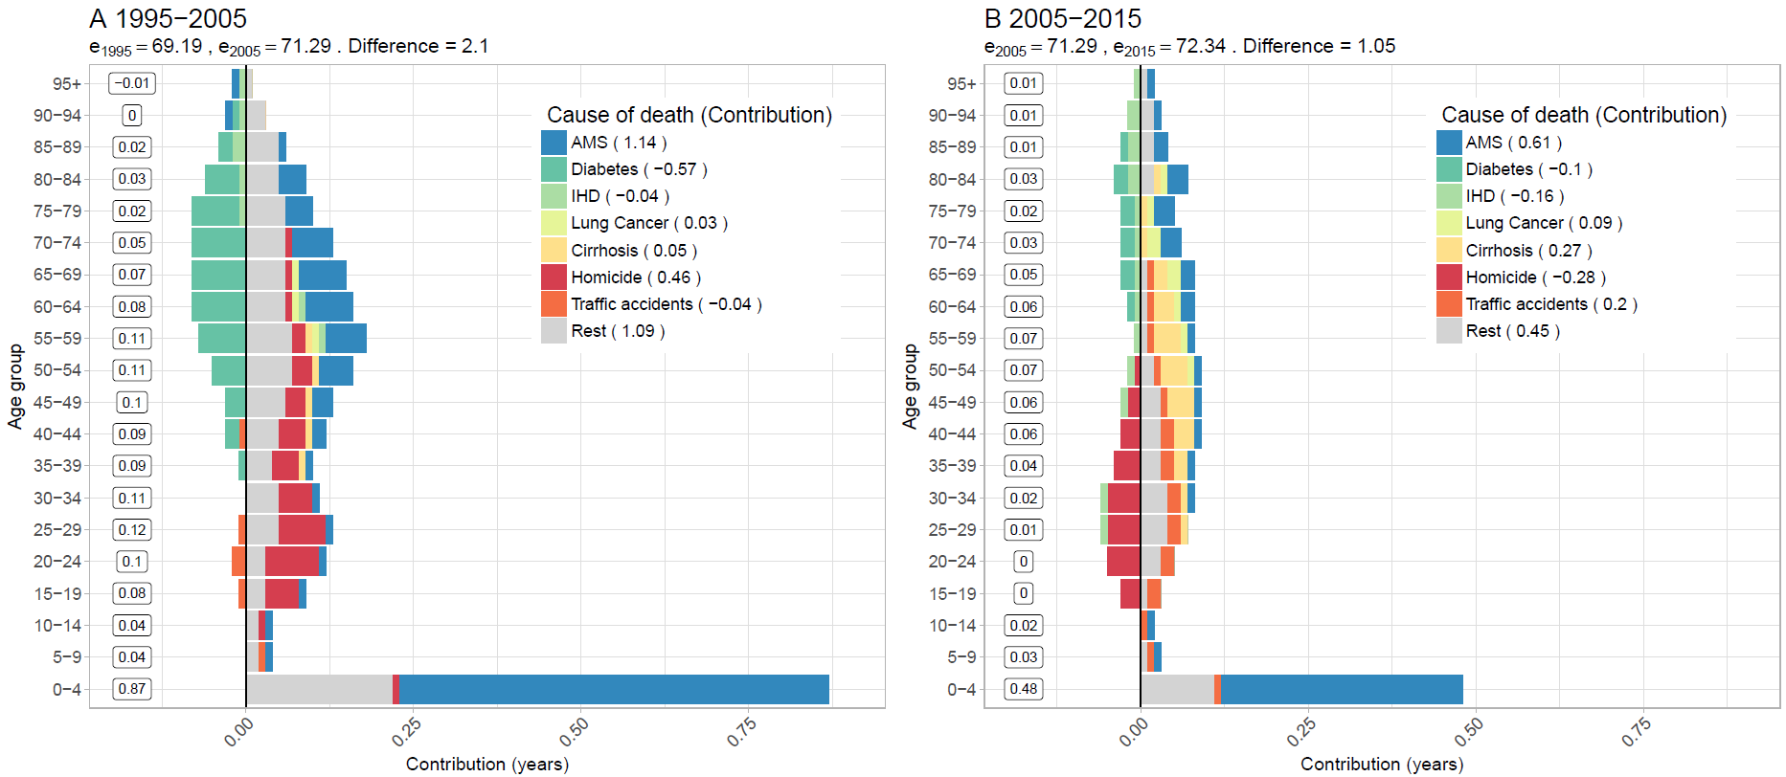**Figure 1. Age-cause specific contributions to the changes in national life expectancy (**e0**) for males. Panel A refers to 1995-2005 and panel B to 2005-2015. Note: Numbers in boxes are age-specific contributions.**

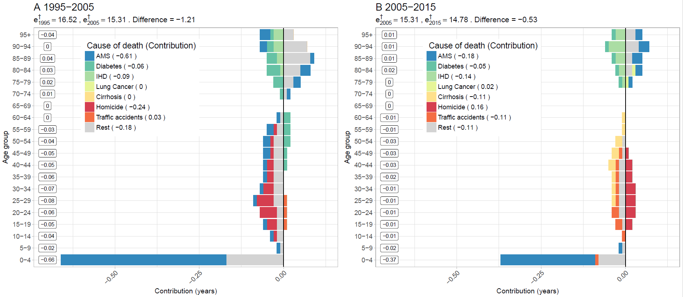**Figure 2. Age-cause specific contributions to the changes in national lifespan variation ($e^{†}$) for males. Panel A refers to 1995-2005 and panel B to 2005-2015. Note: Numbers in boxes are age-specific contributions.**

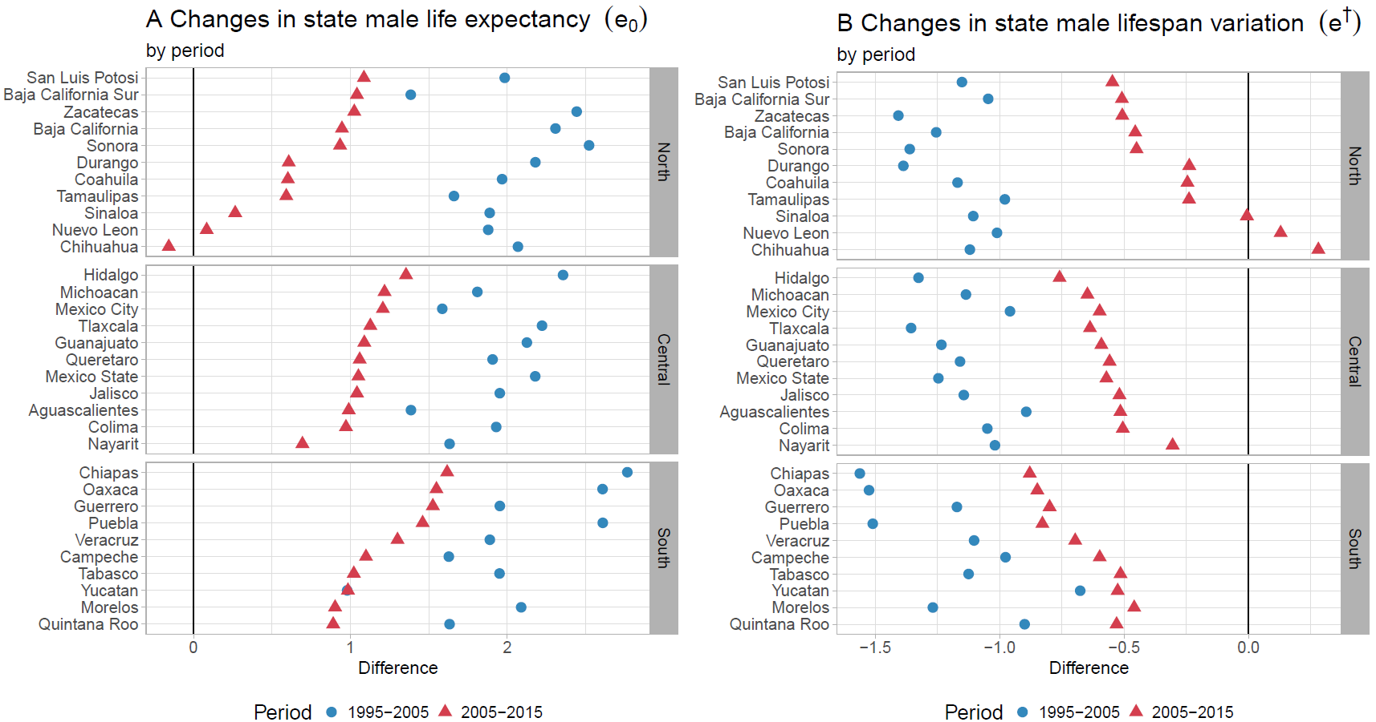**Figure 3. Changes in male life expectancy (**e0**) (panel A) and male lifespan variation ($e^{†}$) (panel B)**

**by state for the periods 1995-2005 and 2005-2015.**

**Figure 4. Cause-specific contributions to changes in male lifespan variation ($e^{†}$) by state for the periods 1995-2005 and 2005-2015.**

